MASCHERPA Audric ROB 3 2022 / 2023

**POLY-SNAKE**

**Weekly report n°4 from 15/11/22 :**

The beginning of this session was about the perfection of the 3D printed piece. Indeed, the program devoted to the movement of the snake being soon finished it was important to be able to finalize the body of the snake before being able to start carrying out the first tests.

Figure 4.1

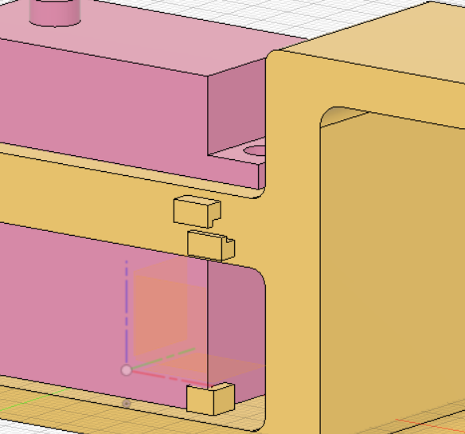

Thus, the dimensions of the 3d printed piece have been revised to be able to accommodate the servomotor more easily, the position of the cables will no longer be below the piece but on the side as shown in figure 4.1 and the size of the printed body has been increased to better suit the Nvidia control card which was too large compared to the initial desired size of the project.

Figure 4.2

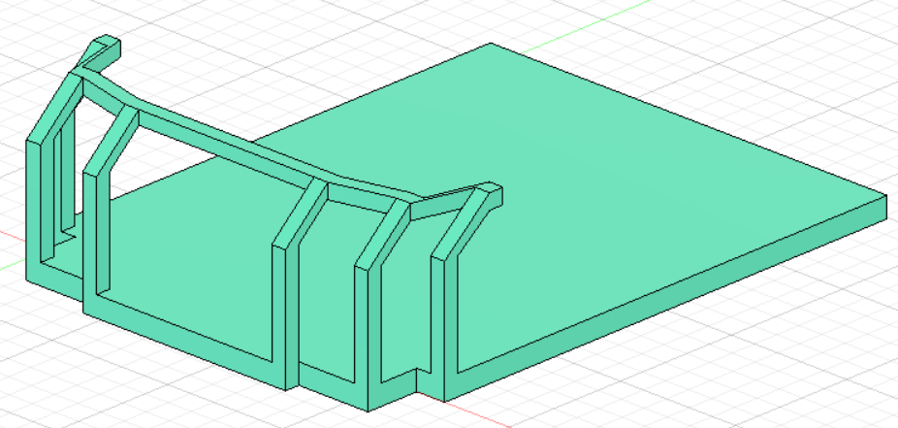

Moreover, while waiting to be able to perform the first tests, I started to think about the design of the snake's head that will accommodate the Nvidia card. We can see in Figure 4.2 the beginning of the 3D modeling of the part after taking the measurements of the Nvidia card.

The next session will therefore be concentrated around the realization of the first tests of the movement of the snake, research on the wiring of the servomotors up to the Nvidia counter card and finally continue the 3D modeling of the head of the snake.